Parvinder Kumar Saxena
Street Address –Pocket-B-43 A, SHIVAM APPARTMENT., ASHOK VIHAR,PHASE-II, NewDelhi-110052(India)
(L)011-27426433 - (M) 9811595302 Email : parvindersaxena@gmail.com
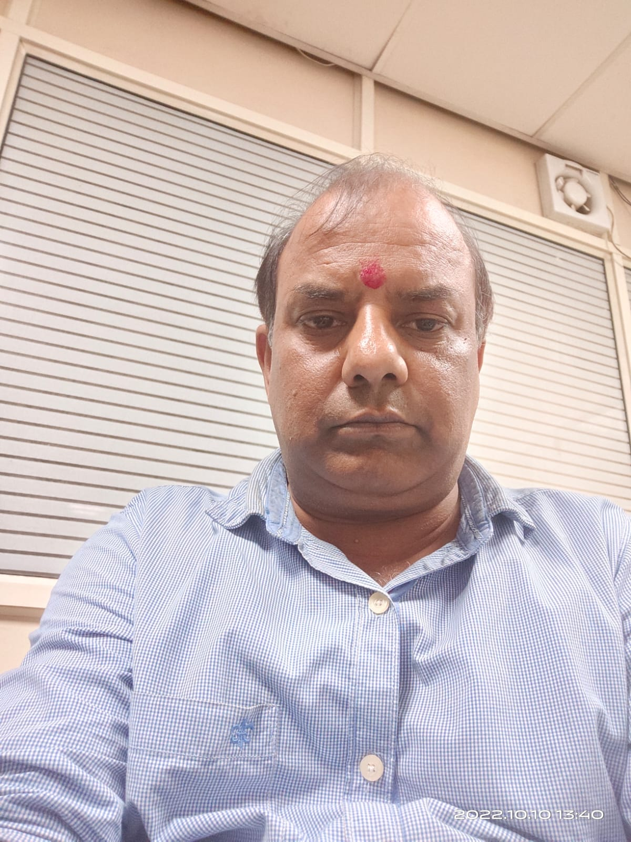

MANAGEMENT PROFESSIONAL
~ Export work from Air & Sea Both Ports~
Track record of leadership, with excellent results in improving overall performance, driving revenue. Expertise in Apparel, clothing, Clearing &Forwarding, including process improvement and implementation. Demonstrated ability to identify.

PROFESSIONAL EXPERIENCE

HOPP WORLDWIDE LTD 1992 – 2001 DEPUTY MANGER

JSS CARGO 2001- 2005 OPERATION INCHARGED
GATEWAY FREIGHT 2005- 2011 OPEATION HEAD
MASCOT INTERNATIONAL 2011- 2016 OPERATION EXECUTIVE
ABX FREIGHT SERVICES 2016-TILL DT. FREIGHT HEAD/MANAGER

In the role of an Operation Incharged in Export Department, we are Knowledge of Export all documentation includes planning. Managed New Business, Servicing processes and was responsible for our duties.

EDUCATION:
➢ 10th passed from C.B.S.E Board
➢ 12th passed from C.B.S.E. Board.
➢ Graduate: Delhi University

PERSONAL ATTITUDE :

- Can Work Well as Part of Groups and Work Well Under Pressure
- Accept Responsibility Show Determination and Strine For Success With In Deadlines
- Learn Quickly, Produce Quality Work and Follow Safety Standards
- Attitude and Maintain Professional Appearance

Roles and Experience:-
- Air & Sea Export Customer Service Desk
- Handling - Quotations, Booking, shipment planning, and liaising/update of shipments
- Co-coordinating with Various Overseas agents, Local Carriers, Vendors - CFS / CHA, Shipping Line
- Sending Pre - alerts, Monitoring Manifestation
- Coordinate SHIPMENT
- Inter-department coordination with Pricing desk, Documentation Desk, Accounts Desk for billing & payment releases to vendors for Timely DO & AWB/ BL release
- Updating Import / Export Job Data in our in-Office software
- Maintaining & updating MIS reports for Customers
- Co-ordinate with Sales Department Resolve Pending Issues
- Looking After Stock
- Co-Ordination with Branch Head

- BANK Filling/Submitted Paper (Export Shipment) for Issue BRC

- I have Cleared Exam a “G” card
- Best Performer, Best Contributor for Business and Best performer for Planned Shipment Custom Clearance.
- Managing New Business for Delhi NCR Region.

PERSONAL DETAILS
- Father Name : Late Shri Surender Kumar Saxena
- Marital Status : Married
- Sex : Male
- Date of Birth : 07, JUN, 1971
- Nationality : Indian
- Languages known : Hindi,& English .
- Hobbies : Working on Computer, Internet Surfing, Studying, Reading
- Mailing Address : Pocket-B, 43 A, Phase-II, Shivam Apartment
Ashok Vihar,
NEW DELHI-110052
(India)

DECLARATION
I here by declare that the above given details are true to the best of my knowledge and belief.

Date:

Place: DELHI (PARVINDER KUMAR SAXENA)

